Performance, Composition and Arranging for the Reverse

Action Piano Harp

Collection Components In Order Of Discussion

- 300 Word Statement - Performance, Composition and Arranging for the Reverse Action Piano Harp
- Critical Commentary: Performance, Composition and Arranging for the Reverse Action Piano Harp 2014-2019 (This document)
- Bach’s Fantasie (Partita No. 3 in A minor BWV: 827) Arr: Brissenden (Version 1)
- Clair de Lune - Debussy (Arr; Brissenden for solo Raph)
- Reverse Action Piano Harp - Website
- Snow All The Way To The Cage - Brissenden, for solo flute and Raph. Performed at Sonic Fusion, February 2015
- Bach’s Fantasie (Partita No. 3 in A minor BWV: 827) Arr: Brissenden (Version 2)
- Bach’s Fantasie (Partita No. 3 in A minor BWV: 827) Arr: Brissenden (Version 3)
- Bach’s Fantasie (Partita No. 3 in A minor BWV- 827) Arr- Brissenden - Performance Recordings
- Audio Illusions & Other Musical Curiosities - Manchester Science Festival 2016
- Audio Illusions & Other Musical Curiosities - Manchester Science Festival 2016 - Raph Performance Edit
- Salud D'Amour - Elgar (Arr: Brissenden for Violin & Raph)
- Salud D'Amour - Elgar (Arr: Brissenden for solo Raph)
- Salud D'Amour - Elgar (Arr: Brissenden for solo Raph - Performance Recording)
- The Fairest Rose (Traditional Arr: Brissenden)
- Hoe Down - Copeland, from Rodeo (Arr: Brissenden for violin and Raph)
- SPARC 2017 - Experimental Instrument Ensemble
- Nocturne (Version I)
- Nocturne (Version 2)
- Study (II)
- Celebration of the Redevelopment of Peel Park. Performance in Conjunction with Walk the Plank 2017.
- Orpheus - footage captured at Project: Trinity 19th November 2018 - Performance by Dr Phil Brissenden (Raph), Dr Adam Hart (Signal processing)
- Salford Festival of Research 2018
- Adelphi Contemporary Music Group Performance in Collaboration with Michael Cretu
- Harp Dream (Brissenden, Shepherd 2019)

Introduction
The Reverse Action Piano Harp (Raph) is a novel musical instrument interface. It consists of a bespoke zither, with playing enhanced through a secondary damping interface. Current prototypes incorporate a traditional keyboard, which provides reverse damping from individual keys, to each octave occurrence of a pitch on the string surface. The interface is designed from a conception of an ideal playing position that provides optimum access for the left hand to address the keyboard and the right hand to address the string surface.

This project has been informed through periods of practice-based research, alternating between design and build (and analysis of the results), and performance, composition and arranging (with similar reflective analysis informing the subsequent design and build phase). The project dates from 2008 and includes a patent (secured 2012) and successful PhD (completed 2015).

This submission focuses in detail upon the performance techniques, acquired and developed subsequent to the completion of prototype 5. This begins with a recognition of the instrument’s learning pathway; the design conception provided almost immediate access to harmonic texture; playing experience on the earlier prototypes 2 and 3 took full advantage of this ease of learning exploring the instrument as a fully chromatic strummed accompanying instrument.

The rite of passage through to more advanced ensemble and solo repertoire has proved more challenging. The challenge found in this transition matches that of the autoharp community of instruments generally – it is at the transition from intermediate to advanced conceptions that autoharp interfaces tend to become esoteric to the point of lock-in, and isolation from the mainstream musical community. The Raph offers better potential at a more general integration, but in order to do so requires the development of advanced technique, notation and learning systems to support it and repertoire to allows its expression.

Since the instrument is unique, an astute strategy has proved to be, to reference and adapt technique from oublique musical angles; flamenco techniques from guitar, tremolo techniques from mandolin/bazouki are the corner stone techniques which are integrated throughout the repertoire within this portfolio. Referencing these back to traditional autoharp techniques and structures is crucial. This has ultimately lead to further critical examination of the range of genres and cultural possibility in which the instrument might successfully function.

This submission documents the performance, composition and arranging work undertaken upon the instrument covering the relevant period for the REF submission; this includes recordings, recordings of performances (in ensemble and solo contexts), scores of compositions and arrangements and analysis of relevant techniques developed upon the instrument.

Autoharp Notation
Although autoharp notation is not suitable for Raph, elements of it certainly need to be integrated into a developing Raph notation system and it is worth the reader understanding its salient features at this point.
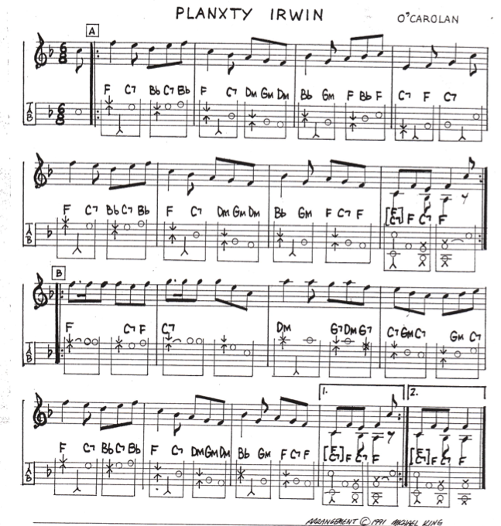
Figure 1 Typical Autoharp Notation (Carolan & King, 1991) Status Public Domain

Autoharp notation uses a two-stave system. The upper stave denotes melody (similar to a normal lead sheet). Below this, between the two staves, chords are indicated, although these are not necessarily a representation of the harmony to be played — some chord bar changes indicate passing notes rather than chords and this is clarified by the lower line notation. Below this is a line of mixed symbols and note heads. The inward facing vertical arrows, on the strong beat of each group of 3 quavers in this arrangement, denote a pinch. The arrow heads indicate the starting notes for each finger, increased width does not necessarily indicate a full width of stroke; note the double chord bar at the first beat at bar 8, which allows the octave Cs to be isolated. On the second quaver beat, where there is no melody note (for example bar 1), an accompanying thumb strum from the lower or middle octave is indicated (lower to higher strings). Also possible as accompaniment (but not used in this arrangement) is a downward arrow, denoting a third finger brush from higher to lower strings. Single notes, which are rather confusingly notated as semibreves, but in fact, follow the melodic line, signal that individual strings should be sounded rather than chords (the change of chord bar is necessary as the passing or auxiliary note is not found within the sounding harmonic chord bar).

This exposes the melodic weakness of the instrument: firstly because the sounding harmonic strings will be silenced at this point; secondly because this accuracy is difficult to achieve, and notes from the passing chord bar are likely (this piece is most commonly and sympathetically rendered with a chord change every three quaver beats and the increased harmonic turnover is not desirable). Note that within section B, the melody is simplified from its most common form (where F rises to G on beat 2 of bar 9 and G rises to A on beat 2 of bar 10) presumably in order that the accompanying strings are able to sound throughout the bar. The lower brackets denote the groupings of three quavers within the time signature, and the tie at bar nine denotes the dotted rhythm in the melody.

This notation achieves a reasonable degree of precision, but is extremely limited given the new possibilities offered by the Raph formulation. However, the technical elements such as pinch and strum combinations do need to be reflected as the notation develops.

Developing Raph Notation and Method
The most obvious means of providing accurate notation on the Raph will again call for two staves, the upper to denote the right hand upon the strings and the lower to denote the left hand on the keyboard. This typical scale-based exercise in G major illustrates this effectively, and the notation can be understood at a glance because it follows piano notation closely in providing precise guidance for each hand.
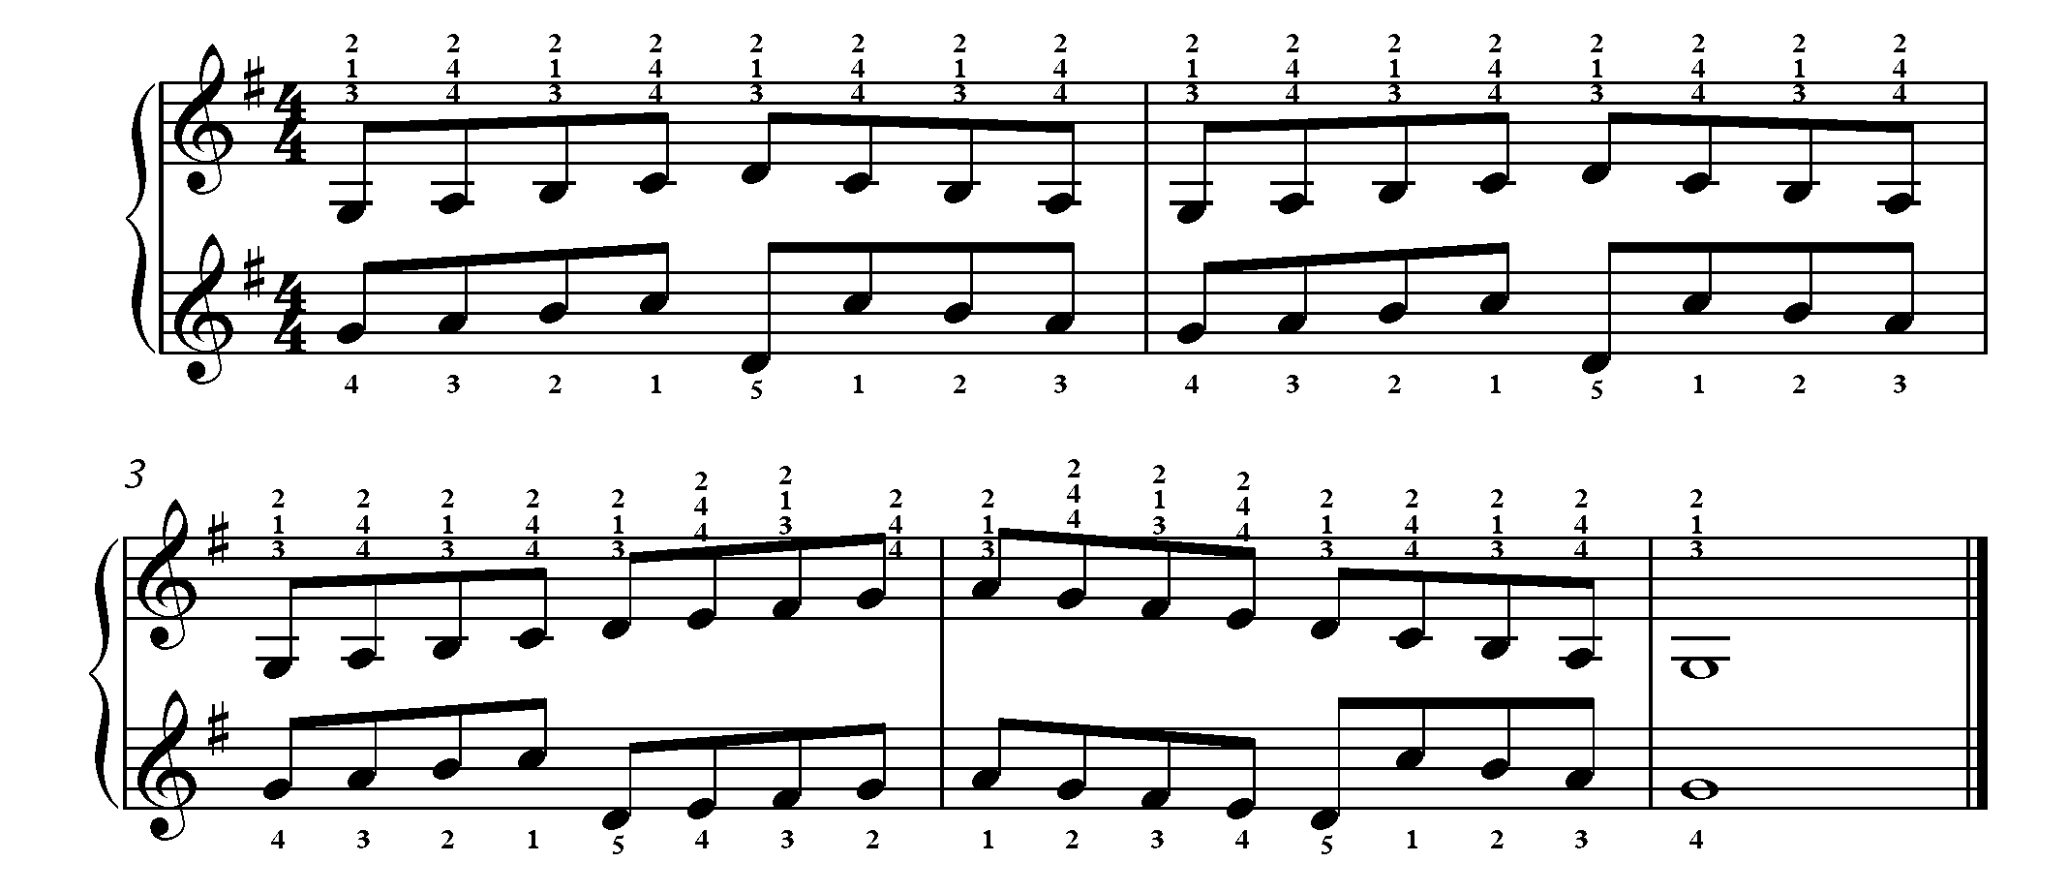
Figure 2. Scale based exercise in G major

The right hand on the string surface has three alternative sets of fingerings, all of which were practiced on prototype 3. The left hand, at the keyboard, follows instruction similar in all aspects to piano notation. The “wrap around” point, which seems to place the two hands in opposing directions, is set at C in this particular exercise. Note that the left hand is notated with treble clef. Piano left hand notation does appear in treble clef quite often (dependent on register), but an arrangement of combined treble and bass clef is by far the most common notation for a pianist to encounter. A reasonable assumption, this being the case, and given at least 40 years of piano experience, is that it would prove most advantageous for Raph arranging, but successive tests proved that, at least for my own reading, the treble-treble arrangement adopted above was always a notch faster than the bass-treble alternative. Based on this well-tested but admittedly subjective finding, and the fact that the left hand notation sits better within the treble staff (only one ledger line at middle C is required) I decided to adopt this arrangement. This scale-based exercise is put forward as typical, and easily be expanded to provide a series of chromatic drills.

Bach’s Fantasie (Partita No. 3 in A minor BWV: 827) Arr: Brissenden (Version 1)
The excerpt from the arrangement of Bach’s Fantasie (Partita No. 3 in A minor BWV: 827) below (and full score – version 1 within the collection) shows how tortured the issue of wrap-around can become within melodic situation; it proved a particular tongue twister. A good deal of the time the two hands are similarly engaged in melodic direction, but the level of octave displacement within the melody itself, combined with the complication of rendering one of the hands within a range of a tenth, means that this piece requires independent thinking between the hands and is in fact more like learning a piano piece.
There are two (sometimes conflicting) selective pressures in arranging for the left hand. Firstly, where possible (and practical) the left hand does mimic the movement of the right hand melody. Note: for bars 25–29 this movement is exact, even though slightly easier arrangements of the left hand might be rendered through octave displacement. A second selective pressure is expressed in bars 1–3 where octave displacements must at least be used for the low A (opening) and B (end of bar 2). Aside from the low A, the first bar and first beat of bar 2 mimic the right hand movement, followed by an octave displacement which allows the downward stepwise movement to be common to both hands for the remainder of the bar. Opposing movement direction in bar 3 (where the music moves only in quavers) allows the left hand to be placed in the correct position to engage in the subsequent quicker semiquaver movement at bar 5, where the movement is similar. An example of a marginal decision is the octave displaced C at the beginning of bar 19; this renders the figuration easier under the left hand, but takes a little more learning altogether, because of the opposing movement. In general an attempt is made to follow the step-wise semi-quaver melodic direction, and to allow the jumps in melodic pitch to displace at the keyboard, and orient the octave such that subsequent step-wise movement can be similar (bars 11–13 illustrate this).
The difference between this level of arranging and the initial chord based reading that I undertook on earlier prototypes is that this formal notation definitely requires learning and a willingness to accept the arranging decisions. Reading the melody line alone is entirely possible, but because of its nature, is prone to stumbles at wrap-around points. Decision-making does improve on successive readings, but in order to completely stabilise it, precise notation is necessary. Reading this notation can be quite frustrating, and initially at least, I found that most favoured decisions at the instrument did not quite match most favoured decisions when arranging away from the instrument.
This example was adapted from a mandolin arrangement of this piece. Compositions and arrangements for this instrument provide a fairly rich melodic repertoire that is highly suitable for adaptation to Raph. Violin repertoire is also adaptive in terms of melodic range, and the baroque style is particularly suitable.
Pinch, the lynchpin of autoharp right hand technique upon the string face, is incorporated into the exercise below. The two note combinations allow a greater precision of pinch to be given by the left hand at the keyboard than using chord bars on an autoharp. “Pinch” here is issued as a score direction, and is denoted by the combination of fingering called for in the right hand (4–1). This exercise would also easily be adapted as a series of chromatic drills.
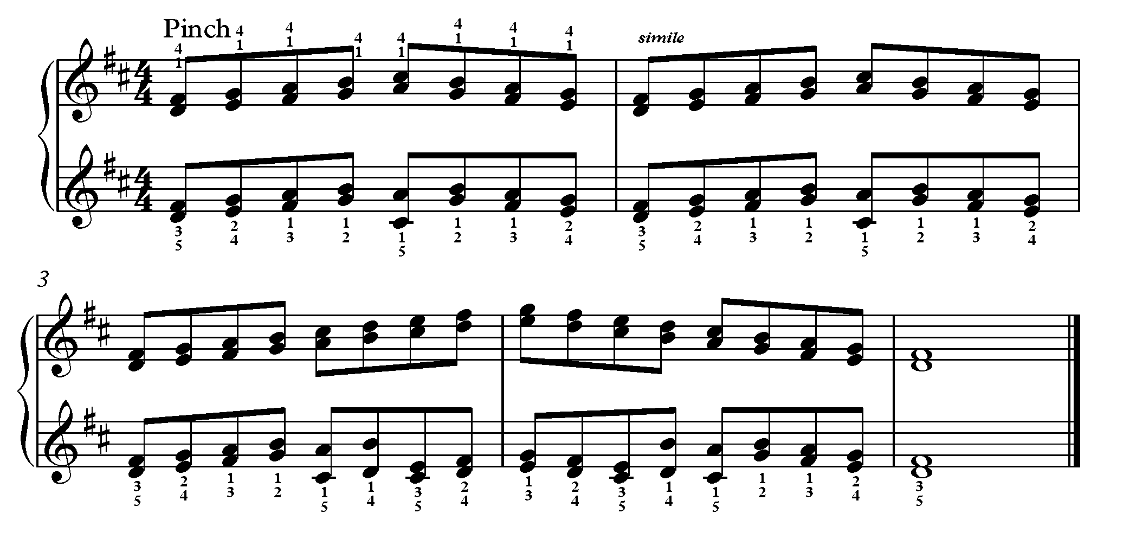
Figure 4. Scale exercise in 3rds in D major

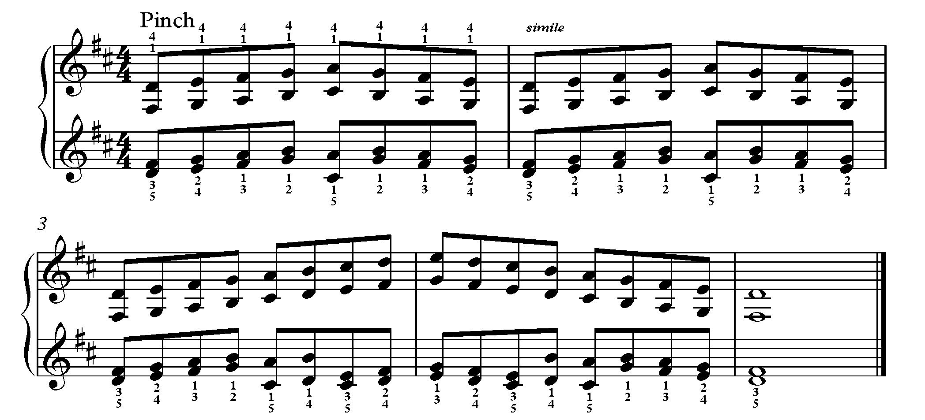
Figure 5. Scale exercise in 6ths in D major (left hand patterns are the same for both)

The notation stands up to the test of this exercise, illuminating the fact that the same left hand patterns can be used for scales in 3rds and 6ths, and that legato at the wrap-around points can be enhanced by changing between 3rds and 6ths in the left hand at appropriate points.

Techniques; Finger-Picks, Thumb-Picks and Nails
“Pinch” as a term, evokes a mental image of the hand motion effectively, but is perhaps an unfortunate descriptor overall because it suggests quite a forceful engagement with the strings. Strum effects across a range of instruments appear to the listener as bright and highly percussive, which belies the small, precise, and above all relaxed movements which actually achieve attractive sound. The best tone for pinch technique is rendered through a smooth attack concentrating on relaxed hand, which absorbs the shock of string engagement easily, and an oblique angle of finger pick engagement.

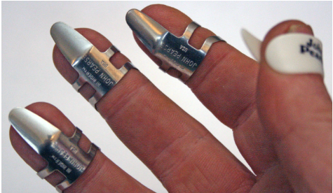
Autoharp players adopt varying numbers of finger-picks, from picks-on-all-fingers, to just thumb and first finger, or no picks at all. This last was initially the most attractive to me (since an ambition of the instrument was that the hand should be in direct contact with the strings). During initial engagement with purely chordal accompaniment, it proved sufficient to simply strum the instrument similarly to guitar strumming. However, my first attempt at copying the technique of Bryan Bowers, using only fingers, left them shredded and bleeding, and it was clear that a rethink, and emergency visit to the music shop was necessary. I thus began to experiment with finger-picks, first adopting metal finger-picks on all fingers — these being the easiest to alter in size for a reasonable fit-to-finger, and a plastic thumb-pick (which I did not like and began alter immediately). The photograph below shows a typical autoharp arrangement.
Figure 6. Typical Autoharp Finger-Pick Arrangement

A limiting factor of finger-picks (when compared to finger engagement) is that they are designed to engage in only one direction. The orientation of the finger-picks in the photograph right, are for downward engagement (treble to bass) and the thumb for upward engagement (bass-treble). I found this arrangement very limiting, because the up strums from the thumb do not easily cover the range of the string surface. I sought a more balanced arrangement by reversing the pick on the third finger such that it provided an alternative up-strum to the thumb, and this arrangement felt immediately more comfortable.

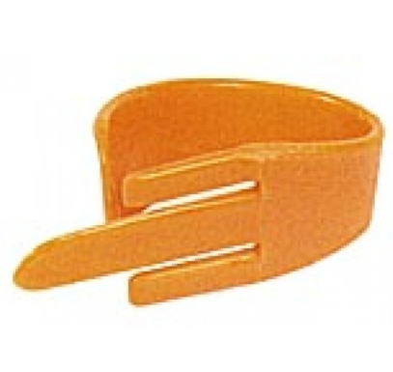
At the UKautoharps meet in Mickleover in September 2012, Mike Fenton, an accomplished autoharpist and winner of various US competitions on the instrument introduced me to the Fred Kelly speed-pick (for thumb), which I found to be a revelation. The minimal, and highly flexible surface area presented to the strings by this pick allows Mike to formulate a tremolo effect using thumb and third finger tucked in line with the thumb, using lateral movement of the hand, similar in technique to the way in which a tremolo chord is achieved on the piano, and similar in sound to mandolin tremolo.
Figure 7. Fred Kelly speed thumb-pick

I was unable to directly copy this technique at the time because of the pick arrangement that I had arrived at (reversed on the third finger).

I discussed the reversed pick variation with Mike in some detail; in keeping with the autoharp community ethos, he was not judgemental in any way, instead he discussed the detail of his own strategies saying that he would be likely to change the number of finger picks that he used depending on the particular piece, from as little as thumb and third only to picks on all fingers. However, he did comment that it was an unusual arrangement.

The Fred Kelly thumb pick delivered a different sound and feel to any finger pick that I had so far encountered. The narrow width means that the pick has a pleasing bounce as it engages the strings; the effect is a reduction in the noise generated, and a clearer sound. It also gave a greater precision than I had previously been able to achieve with the thumb. Thus inspired, I began a further round of experimentation with different shapes, materials and thicknesses of finger pick.
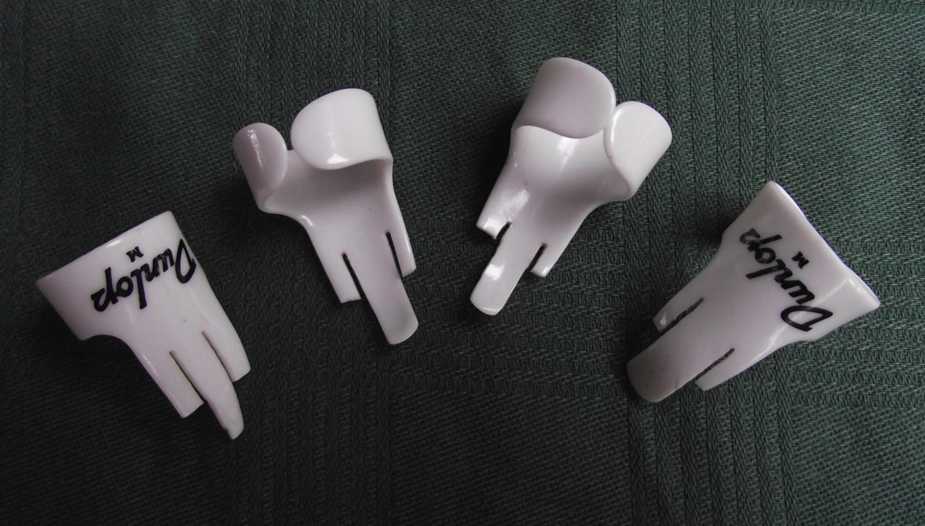
Figure 8.
Various Dunlop finger-picks adapted along the lines of a Fred Kelly speed pick.
More precise sound, and less plectrum noise result from these adaptations
However, eventually in 2015 (now playing the much louder prototype 5) I travelled almost full-circle with this journey and returned to playing with nails save only for the thumb-pick, which remains. By this point my technique was sufficiently accurate that I was able to adapt to a fingernail style without further finger damage, beyond a couple of initial blisters. This is certainly the combination that offers the most freedom, but how can this be reflected in terms of pedagogy? The twists and turns taken in this journey give pause for consideration, because some combinations of finger-picks allow for different potential and require slightly different training and orientation of the supporting technical exercise material. Moreover, based on my own experience, it takes a long time to arrive at sufficient accuracy and finger durability to adopt a fingers + thumb-pick style of playing.

Clair de Lune - Debussy (Arr; Brissenden for solo Raph)
The Raph arrangement of Debussy’s Clair de Lune shows off the ability of the Raph to render performances of some pianistic repertoire. Not all is suitable, and there are no set criteria for establishing that which is, and that which is not, however a guiding principle is that instrument lends itself more towards piano writing that is oriented towards left hand accompaniment and right hand melody — it is difficult to imagine it rendering dense Mozart passagework, for example. Clair de Lune was formally notated for the purpose of the recording. A first version of this score was completed as early 2011 in preparation for a master-class presentation at University of Salford, at which excerpts were performed.
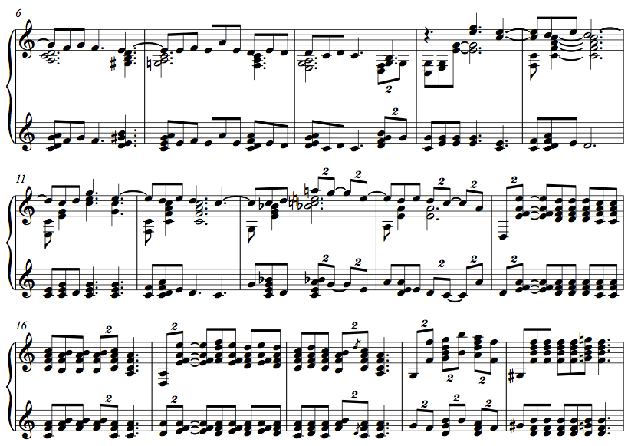
Figure 9. Clair de Lune (excerpt) (version 1 November 2011)

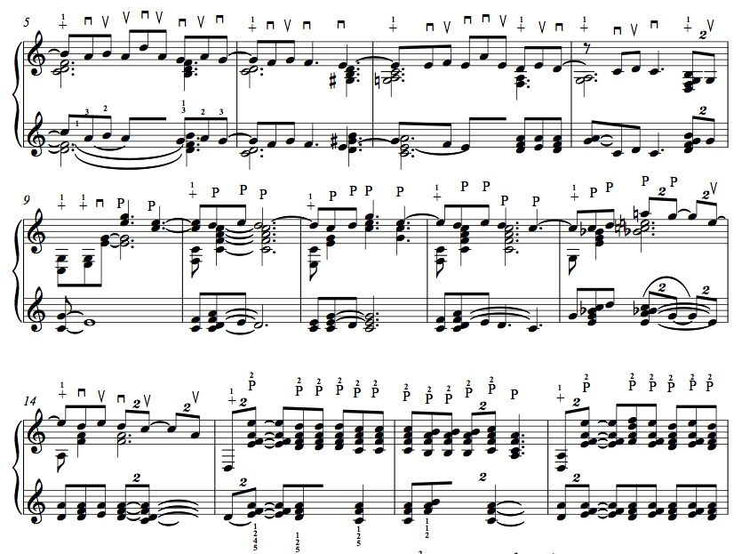

Figure 10. Clair de Lune (excerpt) (version 2 April 2015)

Figure 9 shows that the novel aspects right hand technique upon the string face, with techniques adapted from autoharp technique was very much the focus of attention at the time of producing this version of the score. The left hand at the keyboard is provided with a reduced version of this arrangement limited to one octave, but no further thought was given to illuminating the precision needed in order to render an effective performance at this time.

A similar passage re-worked as late as April 2015 is shown below this (figure 10). Here the left hand has been considered and edited to a similar standard to the right, with precise indication as to which notes are required to be held and released at a given time. Where no change is needed, subsequent notes are hidden using the notation software, and precise use of ties (often illegal in the strictest sense) illuminate notes that are required to be held. The effect appears more like Schenkerian analysis than score based cues, however it does result in much more precise performance. The right hand is further annotated with precise strum/pluck directions, capturing the essence of autoharp right-hand technique, and developing it. These directions also enhance the precision of the performance. The technique to accomplish these score directions quickly and accurately developed in the intervening period and benefitted considerably from collaborative practice and ensemble engagement with the Adelphi Contemporary Music Group.

Key to Score Directions
– Denotes a pinch (assumed with 3rd finger as a default)
– Denotes a pinch with 2nd finger
– Denotes an up-strum (from bass to treble) with the 3rd finger
– Denotes a brush down (from treble to bass) with the 3rd or 4th finger
– Denotes a thumb only up-strum (from bass to treble)

Up-strum has been described throughout this text in relation to pitch (bass to treble). Generally this falls on the strong beats, and it is therefore logical to use a down-bow symbol to denote this despite the description of up-strum.

Two further passages illuminate the simplification that this score-design provides for the left hand in faster semi-quaver passages — the left hand changes are placed at the equivalent point that the sustain pedal would be changed at the piano.
Figure 11. Clair de Lune (excerpt) (version 1 November 2011)
Figure 5.16. Clair de Lune (excerpt) (version 1 November 2011)
Figure 5.17. Clair de Lune (excerpt) (version 2 April 2015)
Figure 12. Clair de Lune (excerpt) (version 2 April 2015)

As in the original piece, three staves were needed to render the musical intent clear at times during this piece, and this became common practice in later Raph arranging. The current edition of this arrangement, which has been revised continuously throughout the duration of this entire project is included as part of the collection (Clair de Lune - Debussy (Arr; Brissenden for solo Raph)) and the piece has been performed with some regularity at MA masterclasses and at the UoS festival of research 2018, a link to a soundcloud 2012 recording appears on the main www.reverseactionpianoharp.com (also included in the collection).

Chris Lawry – Composer/Pianist – Be Still My Soul (recorded January 2014) - Reverse Action Piano Harp - Website

Chris Lawry is an accomplished composer and pianist. He was a Master’s student at the University of Salford from 2013–14, and attended the Raph master-class, which was timetabled early during that particular academic year (October 4th). Chris was immediately interested, and full of detailed questions regarding notation. He was particularly concerned about issues of sustain. He played the instrument for some time after the presentation, and later in the semester we had a further one-to-one session where Chris played some of the textures that he was imagining for his piece, and we discussed elements of notation and blend with the piano. We also agreed on a timetable and technical approach to the completion of the project.

The piece is a setting of A. E. Housman poetry from A Shropshire Lad for voice (soprano/tenor range), piano and Raph; the style, evocative of Vaughan Williams and other examples of early twentieth century English song. The Raph part is designed to provide a timbral counterpoint to the piano accompaniment, sometimes through contour, but often sitting directly over the piano part and providing timbres that the piano cannot. Chris described the sound of the Raph as “Hollow and resonant like a harp, but with much greater flexibility as to how chords can be selected and played” (Lawry, 2013); his focus was certainly on its harp-like properties, which had not been such a focus in my own arranging to this point. He also seemed to grasp the essence of notating for it immediately, and created a clear part, which could be immediately sight read and comfortably practiced against the recording.

Figure 13. Excerpt from Be Still My Soul (Lawry, Be Still My Soul, 2013)
Status: Permission Granted

This notation (from an independent composer) represents a considerable step forward in terms of engagement with the musical community. It is entirely consistent with, and develops my own ideas on notation — it looks and feels like a Raph part. Moreover, the ensemble role is different to anything that I had written to this point. The harp-like textures and glissandi had not featured to a significant extent in my presentations of the instrument.

Not everything was quite as Chris initially imagined it to be in performance, and during rehearsal we agreed some changes. Subsequently, I overdubbed the Raph part in my studio and Chris re-notated the score to reflect the changes, the same excerpt is shown below in re-notated form.
Figure 14. Excerpt from Be Still My Soul (Lawry, Be Still My Soul, 2013) – final version
Status: Permission Granted

There is some detail to draw out from the score; slower harmonic turnover in the second line (one chord per bar) is reflected in the left hand, which is sustained through the bar. In the excerpt below, for the first time, bowing marks are adopted to ensure that strum patterns are precisely indicated and rendered similarly each time.
Figure 15. Excerpt from Be Still My Soul (Lawry, Be Still My Soul, 2013) – final version
Status: Permission Granted

These details, which make a considerable difference to the precision and simplicity of the notation, emerged from the detailed discussion with Chris.

The overall technical standard required to perform the piece, which I would assess as intermediate, represents a slightly less ambitious level of playing than I had been attempting in other notated repertoire. It is similar in principle to playing songs from lead sheets, but brings precision of performance direction and sophistication. A link to a www.soundcloud.com recording of this piece provided from the main website www.reverseactionpianoharp.com which is included in the collection.

Snow All The Way To The Cage - Brissenden, for solo flute and Raph. Performed at Sonic Fusion, February 2015

The Cage is a folly found in Lyme Park in East Cheshire. This imposing building stands at the summit of a hill, which provides views to Kinder Scout and the hills around Edale to the East, and an inspiring view of Stockport and Manchester to the West. On a clear day the Beetham tower can easily be picked out from the summit. Similarly, the Cage imposes itself as a landmark that can be seen from all of the surrounding hills. The inspiration for this piece was provided by a memorable walk in January 2015. This walk did not take place on a clear day, and the Cage, impressively glazed in snow, was often the only visible landmark from various viewpoints on the walk, as swirling mist alternately cleared and descended around it.

Aside from this extra-musical inspiration, there were several technical aspects of the instrument that I wanted to demonstrate within this piece. The first is illustrated in the excerpt below.
Figure 17. Excerpt from Snow all the way to the Cage (Brissenden P. G., 2015)
The full range of the Raph is used within this passage, but presented through small and precise combinations of strings with varying timbres. The second is a repeated accompanying chromatic figure that gives a feeling of simple contrapuntal movement within the figuration itself; the upper line moves alternately in quavers and crotchets, a slower, underpinning movement in minims (given by the movement between F and E) gives an impression of contrary motion. The flute part swirls around this ostinato and provides the foreground of the piece.

Figure 18. Excerpt from Snow all the way to the Cage (Brissenden P. G., 2015)

A third texture that I wanted in this piece was heavily influenced by Chris Lawry’s harp-like textures within Be Still My Soul. To this point, I had tended to avoid obvious glissandi structures in Raph arranging and composition; these are relatively easy to achieve, and are very often over-used in amateur autoharp performance, to the point that they become tiresome. Better autoharp players do not use these techniques very much at all, and instead value more highly the ability to isolate groups of pitches effectively. Perhaps I had, during my now significant contact with the community, unwittingly picked up some of this prejudice. I now realised that the ability of the instrument to produce these effects remains a strength, and a unique property, which when well used, is one of its most impressive features. Therefore, at bar 62, the Raph is finally allowed to occupy the foreground of the piece with its own swirling textures, based on glissandi and tremolo effects.
Figure 19. Excerpt from Snow all the way to the Cage (Brissenden P. G., 2015)

The piece was performed at the finale of the Sonic Fusion Festival in February of 2015. Danny Thompson, a highly versatile woodwind player, played the flute part. A video of the live performance at Sonic Fusion was captured, and the full score is also included within the collection (Snow All The Way To The Cage - Brissenden, for solo flute and Raph. Performed at Sonic Fusion, February 2015).

Bach’s Fantasie (Partita No. 3 in A minor BWV: 827) Arr: Brissenden (Version 2, 3 and Performance Recordings)
Three arrangements of Bach’s Fantasie (Partita No. 3 in A minor BWV: 827) Arr: Brissenden (version 1 discussed previously within this document) are included within this collection and the reworking of the arrangement of this piece, from which I have learned a great deal; in terms of both notation and performance, illustrates change over roughly a five year period. Versions 2 and 3 also illustrate clearly a difference of conception that can occur for primarily melodic pieces where the advantages and disadvantages to slightly different approaches to notation are not at all clear.
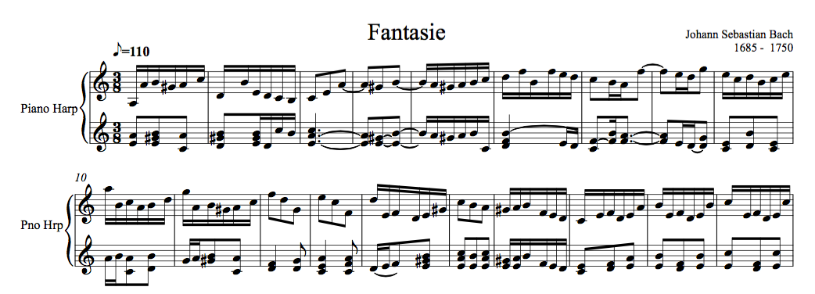
Figure 20. Excerpt from Bach’s Fantasie (Partita No. 3 in A minor BWV: 827) Arr: Brissenden (version 2 – 2012-15)

In a similar way to figures 11 and 12 (Debussy’s Clair de Lune) the left hand has been reconsidered in this arrangement from the extract in version 1 discussed earlier, in ordere to provide a clearer impression of harmonic direction. Indeed, this left hand includes notes not found in the right hand melody at all. Since keys are passive – no precise notation as to where on the string face this E should be rendered is provided. An alternative is the later version 3 below;

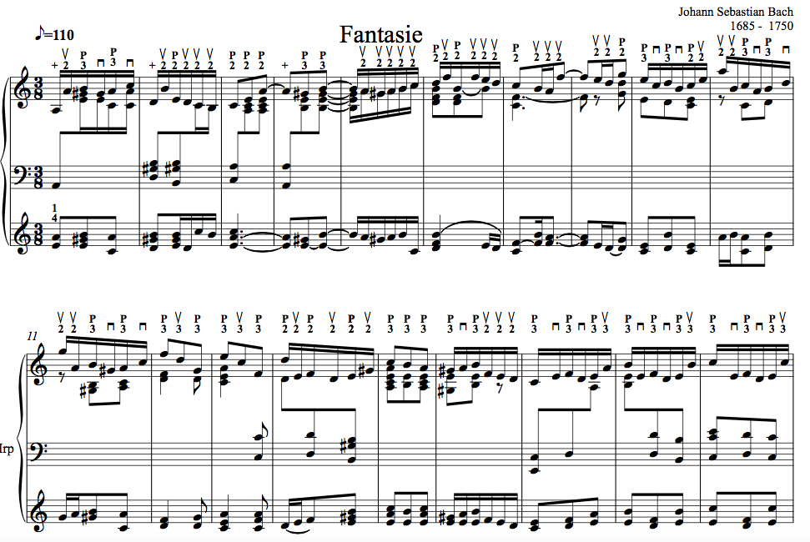
Figure 21. Excerpt from Bach’s Fantasie (Partita No. 3 in A minor BWV: 827) Arr: Brissenden (version 3 – 2014-17)

this captures all of the necessary detail of harmonic/melodic combination. However concluding that this is a superior method of notation is not a simple matter. The level of detail in version three necessitates the use of three staves throughout the piece. This is ultimately more complicated notation than for piano. This is perhaps to be expected when considering the differing modes of engagement. In effect, each hand on the Raph attempts to play a version of that which would be rendered by both hands on a piano and each with distinct modes of engagement; the left hand on the restricted keyboard, and the right hand on the string face. The resulting level of detail renders sight-reading particularly difficult. And all in all, this piece emerges after all of the difficulties as towards the higher end of technical accomplishment – for what was in fact a relatively simple piece. Further, the simpler notation of version 2, though it may omit detail, remains a conceptually clear and above all an economic approach to notation – and these advantages should not be lightly disimissed in considering issues of standardization.

Two recordings, made during a period of intense practice in 2018 are the final components within this section. These are not studio recordings – the capture is from the Piezzo pickup on the back of prototype 5. However, the individual takes of long sections of music have been edited and prepared as if this were a studio capture. The idea of these recordings is to experiment with various combinations of tremolo based melodic/harmonic combination – to experiment with interpretation and arrangement directly upon the instrument. Two final recordings were prepared from these sessions.

Audio Illusions & Other Musical Curiosities - Manchester Science Festival 2016
The challenge for this piece was to combine some of the disparate elements of the lecture part of the project into a coherent musical presentation. The lecture itself consisted of a series of audio illusions, which provide insight into how the brain processes discrete frequency against timbre. The last of these illusions is the well-known Shephard tone. This and other aspects of additive synthesis were selected as providing the abstract background for a Raph performance. A further key aspect of the preparation was to bear in mind that the Manchester Science Festival is very much aimed with young audiences in mind – so a musical presentation should perhaps not become so experimental as to render it unapproachable. The exposition and recapitulations then, are straight renderings of a tune – in D minor, against which the additive synthesis provides a timbral backdrop.

Two further aspects deserve comment. Firstly this was the first attempt to render melody through tremolo – the technique, not supported through any clear knowledge of flamenco strum patterns at this stage, but with some knowledge as to how mandolin players approached tremolo. Secondly the use of right hand half damping of the strings that allows clear combinations of high harmonics to form. This is a common technique for autoharp players – necessitated by the design of the instrument, but one that can equally be applied to the self-damping Raph. Its use, leads to a planned homogenizing of the two sound sources such that it becomes difficult for the listener to separate the additive synthesis from the Raph harmonics – a clear illustration of the techniques developed during the lecture.

Salud D'Amour - Elgar (Arr: Brissenden for Violin & Raph, solo Raph – and performance recording)
In contrast to the previously discussed Bach Partita, arrangement for the Raph resulted in a pleasingly approachable technical standard, comparable with that of the originating piano part in duet with violin, with all of the elements of the piano part rendered clearly. Further consideration of this piece resulted in a solo Raph arrangement, rendered (at least initially) using the two stave method seen in version 2 of the Bach Partita discussed earlier. The violin duet was played at the UoS Festival of research 2018 and later that year at an MA Music Masterclass. A recording of the Raph solo arrangement is included in this collection. Like the recording of the Bach Partita this is not a studio standard recording but is a practice session capture from the piezzo pickup that has been edited and produced as if it were a studio capture. The resulting recording sheds light on the development of the tremolo technique – now informed by a significant absorption and adaptation of flamenco strumming techniques.

Two further arrangements are provided as indicative illustrations of the further exploration of violin repertoire, and the technique of tremolo melody on the Raph (The Fairest Rose (Traditional Arr: Brissenden) and Hoe Down - Copeland, from Rodeo (Arr: Brissenden for violin and Raph).

SPARC 2017 - Experimental Instrument Ensemble
This performance was undertaken in collaboration with Dr Adam Hart, and Aden Peets – both of whom had also developed experimental instruments. Adam Hart is a highly experienced technology based performer of experimental music; but within the context of this performance and subsequent recordings he played a digital theramin developed using a Leap Motion sensor. Aden Peets is a graduate of the MA Music at UoS, whose final negotiated project was the development of a MAX/MSP enhanced Udu; clay pot drum. The Max patch works with the feedback from a contact microphone placed on the udu. The quartet is complete by Professor Alan Williams, whose approach to the piano accordion is sufficiently experimental in itself as to complement to the other elements.

The well-received performance at SPARC was followed with a studio session, from which the three recordings presented were developed.

Nocturne (Version I & II) and Study (II)
These two pieces, conceived as pieces of significant technical ambition – and native to the Raph were composed during the academic year 17-18. Nocturne is the first to reach completion, and its exploration of the techniques learned and assimilated from various technical sources is wide ranging. The technical ambition of this piece is such however that it remains beyond my current performance capabilities however. Study (II) (a working title only) attempts a slightly easier technical standard – comparable to the solo arrangement of the Elgar Salud D’Amour. Both pieces are currently in the practice regime and recordings are planned in due course.

The final five components of this collection;
- Celebration of the Redevelopment of Peel Park. Performance in Conjunction with Walk the Plank 2017.
- Orpheus - footage captured at Project: Trinity 19th November 2018 - Performance by Dr Phil Brissenden (Raph), Dr Adam Hart (Signal processing)
- Salford Festival of Research 2018
- Adelphi Contemporary Music Group Performance in Collaboration with Michael Cretu
- Harp Dream (Brissenden, Shepherd 2019)
Serve as indicative examples of the performance, recording and collaboration work undertaken during the period 2014 – 19, where the Raph has moved from and instrument in development to a hard-working prototype instrument playing music in a variety of genres and performance contexts.

Conclusions
The difficulty of accounting for musical engagement undertaken on the Raph is that it cannot demonstrate the linear process of Action Research as applied to the design process. Some work aspires to raise the profile of the instrument, some to develop and explore aspects of technique, some is simply opportunistic experimentation and collaboration. Throughout the chapter I have endeavoured to provide a sense of the aspiration of each documented case and balance subject distinction with the need to provide a reasonable sense of chronology, which gives a sense of the development activity over time. Despite the complexity, we can draw some conclusions from this narrative with respect to the original research questions.

With respect to pedagogy, a progress-stage similar to that of design distribution has been achieved. This can be summarised:
      - A logical sequence of technical progression has been explored which takes account of the intended variety of genre engagement of the instrument, and more systematic and exhaustive arranging and composition has begun.
      - Notation has been developed which is evolutionary from piano and autoharp notation, which allows for development of repertoire at all levels. Problems of consistency of approach have been explored.
      - The balance of skills and likely level of aspiring Raph players has been critically examined from a number of different standpoints, such that a logical sequence of technical acquisition is emerging.
      - Exploration of the Raph within a variety of genre settings, and adaptation of repertoire from suitable instruments has provided a vision of the strength of the genre range.
      - Depending on the perspective taken; within the period of development 2014-19 the Raph has achieved a good measure of acceptance within the musical community, an underlying aspiration of all activity (design and musical engagement) within this project as a whole.

