SMAG Data Design
MOVE

Contents
Normalisation 3
Raw Data 3
Sensor Data 1st Pass 4
Sensor Data 2nd Pass 6
Sensor Data 3rd Pass 8
Notes 9
Corrected Sensor Data 10
Notes 10
Corrected Sensor Data 2nd Pass* 11
Notes 11
Corrected Sensor Data 3nd Pass* 12
User Data 13
Entity Relations 14
Raw Data 14
Sensor Data 1st Pass 15
Sensor Data 2nd Pass 16
Sensor Data 3rd Pass 17
Corrected Sensor Data 18
Corrected Sensor Data 2nd Pass 19
User Data 20
Data Dictionaries 21
Sensors 21
Sensors 21
Readings 22
Data Types 23
Plot Labels 23
Battery Status 24
Signal Status 24
Pending Changes 25
Sensor Voltage 25
Miscellaneous 26
Applications 26
Networks 26
Accounts 26
Gateways 27
Users 28
Users 28
Admins 28
Passwords 29
Permissions 29
Future Work 30
Location Included Normalisation 30
Gateway Data Normalisation 30

Normalisation

Raw Data
UNF  Repeating attributes indented | 1NF  Remove repeating attributes and identify a primary key | 2NF  Remove partial dependencies | 3NF  Remove non-key dependencies
sensorID  sensorName  applicationID  networkID  dataMessageGUID  sensorState  messageDate  rawData  dataType  dataValue  plotValues  plotLabels  bateryLevel  signalStrength  pendingChange  voltage  gatewayID  gatewayName  accountID  messageType  gatewayPower  batteryLevel  gatewayDate  gatewayCount  signalStrength  pendingChange | sensorID  sensorName  applicationID  networkID  dataMessageGUID  sensorState  messageDate  rawData  dataType  dataValue  plotValues  plotLabels  bateryLevel  signalStrength  pendingChange  voltage | sensorID  sensorName  applicationID  networkID  dataMessageGUID  sensorState  messageDate  rawData  dataType  dataValue  plotValues  plotLabels  bateryLevel  signalStrength  pendingChange  voltage | sensorID  sensorName  applicationID*  dataMessageGUID  sensorState  messageDate  rawData  dataType  dataValue  plotValues  plotLabels  bateryLevel  signalStrength  pendingChange  voltage
 | gatewayID  gatewayName  accountID  messageType  gatewayPower  batteryLevel  gatewayDate  gatewayCount  signalStrength  pendingChange | gatewayID  gatewayName  accountID  messageType  gatewayPower  batteryLevel  gatewayDate  gatewayCount  signalStrength  pendingChange | gatewayID  gatewayName  accountID*  networkID*  messageType  gatewayPower  batteryLevel  gatewayDate  gatewayCount  signalStrength  pendingChange
 | accountID  accountName | accountID  accountName | accountID  accountName
 | networkID  networkName | networkID  networkName | networkID  networkName
 | applicationID  applicationName | applicationID  applicationName | applicationID  applicationName

Sensor Data 1st Pass
UNF  Repeating attributes indented | 1NF  Remove repeating attributes and identify a primary key | 2NF  Remove partial dependencies | 3NF  Remove non-key dependencies
sensorID  sensorName  applicationID  networkID  dataMessageGUID  sensorState  messageDate  rawData  dataType  dataValue  plotValues  plotLabels  bateryLevel  signalStrength  pendingChange  voltage  gatewayID  gatewayName  accountID  messageType  gatewayPower  batteryLevel  gatewayDate  gatewayCount  signalStrength  pendingChange | sensorID  sensorName  applicationID  networkID  dataMessageGUID  sensorState  messageDate  rawData  dataType  dataValue  plotValues  plotLabels  bateryLevel  signalStrength  pendingChange  voltage | sensorID  sensorName  applicationID  networkID  dataMessageGUID  sensorState  messageDate  rawData  dataType  dataValue  plotValues  plotLabels  bateryLevel  signalStrength  pendingChange  voltage | sensorID  sensorName  applicationID  dataMessageGUID  sensorState  messageDate  rawData  dataType  dataValue  plotValues  plotLabels  bateryLevel  signalStrength  pendingChange  voltage
 | gatewayID  gatewayName  accountID  messageType  gatewayPower  batteryLevel  gatewayDate  gatewayCount  signalStrength  pendingChange | gatewayID  gatewayName  accountID  messageType  gatewayPower  batteryLevel  gatewayDate  gatewayCount  signalStrength  pendingChange | aqID  sensorID*  messageDate  gPerM3  PM1  PM2.5  PM10  units
 | accountID  accountName | accountID  accountName | co2ID  sensorID*  messageDate  instantaneous  twa  units
 | networkID  networkName | networkID  networkName | avID  sensorID*  messageDate  airVelocity  temperature  airVelocityUnits  temperatureUnits
 | applicationID  applicationName | applicationID  applicationName | motionID  sensorID*  messageDate  value
temperatureID
sensorID*
messageDate
temperature
units
lightID
sensorID*
messageDate
LuxData
LightDetect
units
humidityID
sensorID*
messageDate
humidity
temperature
dewpoint
gramsPerKilogram
humidityUnits
temperatureUnits
dewpointUnits
framsPerKilogramUnits
gatewayID
gatewayName
accountID
messageType
gatewayPower
batteryLevel
gatewayDate
gatewayCount
signalStrength
pendingChange

Sensor Data 2nd Pass
UNF  Repeating attributes indented | 1NF  Remove repeating attributes and identify a primary key | 2NF  Remove partial dependencies | 3NF  Remove non-key dependencies
sensorID  sensorName  applicationID  networkID  dataMessageGUID  sensorState  messageDate  rawData  dataType  dataValue  plotValues  plotLabels  bateryLevel  signalStrength  pendingChange  voltage  gatewayID  gatewayName  accountID  messageType  gatewayPower  batteryLevel  gatewayDate  gatewayCount  signalStrength  pendingChange | sensorID  sensorName  applicationID  networkID  dataMessageGUID  sensorState  messageDate  rawData  dataType  dataValue  plotValues  plotLabels  bateryLevel  signalStrength  pendingChange  voltage | sensorID  sensorName  applicationID  networkID  dataMessageGUID  sensorState  messageDate  rawData  dataType  dataValue  plotValues  plotLabels  bateryLevel  signalStrength  pendingChange  voltage | sensorID  sensorName  applicationID*  networkID*  dataMessageGUID  sensorState  messageDate  rawData  dataType  dataValue  plotValues  plotLabels  bateryLevel  signalStrength  pendingChange  voltage
 | gatewayID  gatewayName  accountID  messageType  gatewayPower  batteryLevel  gatewayDate  gatewayCount  signalStrength  pendingChange | gatewayID  gatewayName  accountID  messageType  gatewayPower  batteryLevel  gatewayDate  gatewayCount  signalStrength  pendingChange | aqID  sensorID*  messageDate  gPerM3  PM1  PM2.5  PM10  units
 | accountID  accountName | accountID  accountName | co2ID  sensorID*  messageDate  instantaneous  twa  units
 | networkID  networkName | networkID  networkName | avID  sensorID*  messageDate  airVelocity  temperature  airVelocityUnits  temperatureUnits
 | applicationID  applicationName | applicationID  applicationName | motionID  sensorID*  messageDate  value
temperatureID
sensorID*
messageDate
temperature
units
lightID
sensorID*
messageDate
LuxData
LightDetect
units
humidityID
sensorID*
messageDate
humidity
temperature
dewpoint
gramsPerKilogram
humidityUnits
temperatureUnits
dewpointUnits
framsPerKilogramUnits
gatewayID
gatewayName
accountID*
messageType
gatewayPower
batteryLevel
gatewayDate
gatewayCount
signalStrength
pendingChange
accountID
accountName
networkID
networkName
applicationID
applicationName

Sensor Data 3rd Pass
UNF  Repeating attributes indented | 1NF  Remove repeating attributes and identify a primary key | 2NF  Remove partial dependencies | 3NF  Remove non-key dependencies
sensorID  sensorName  applicationID  networkID  dataMessageGUID  sensorState  messageDate  rawData  dataType  dataValue  plotValues  plotLabels  bateryLevel  signalStrength  pendingChange  voltage  gatewayID  gatewayName  accountID  messageType  gatewayPower  batteryLevel  gatewayDate  gatewayCount  signalStrength  pendingChange | sensorID  sensorName  applicationID  networkID  dataMessageGUID  sensorState  messageDate  rawData  dataType  dataValue  plotValues  plotLabels  bateryLevel  signalStrength  pendingChange  voltage | sensorID  sensorName  applicationID  networkID  dataMessageGUID  sensorState  messageDate  rawData  dataType  dataValue  plotValues  plotLabels  bateryLevel  signalStrength  pendingChange  voltage | sensorID  sensorName  applicationID*  networkID*  dataMessageGUID  sensorState  bateryLevel  signalStrength  pendingChange  voltage
 | gatewayID  gatewayName  accountID  messageType  gatewayPower  batteryLevel  gatewayDate  gatewayCount  signalStrength  pendingChange | gatewayID  gatewayName  accountID  messageType  gatewayPower  batteryLevel  gatewayDate  gatewayCount  signalStrength  pendingChange | aqID  sensorID*  messageDate  gPerM3  PM1  PM2.5  PM10  unitID*
 | accountID  accountName | accountID  accountName | co2ID  sensorID*  messageDate  instantaneous  twa  unitID*
 | networkID  networkName | networkID  networkName | avID  sensorID*  messageDate  airVelocity  temperature  airVelocityUnitID*  temperatureUnitID*
 | applicationID  applicationName | applicationID  applicationName | motionID  sensorID*  messageDate  value
temperatureID
sensorID*
messageDate
temperature
unitID*
lightID
sensorID*
messageDate
LuxData
LightDetect
unitID*
humidityID
sensorID*
messageDate
humidity
temperature
dewpoint
gramsPerKilogram
humidityUnitID*
temperatureUnitID*
dewpointUnitID*
framsPerKilogramUnitID*
gatewayID
gatewayName
accountID*
messageType
gatewayPower
batteryLevel
gatewayDate
gatewayCount
signalStrength
pendingChange
unitID
unitName
accountID
accountName
networkID
networkName
applicationID
applicationName

Notes
This line of normalisation is flawed and needs to be re-done from the raw data.
This is because repeating attributes are introduced to the data through the normalisation process, such as the repetition of the data values themselves as they would need to be processed and stored into different tables.
A better solution is to maintain a single table for all the data values but pre-process them into a format that can be easily queried.

Corrected Sensor Data
UNF  Repeating attributes indented | 1NF  Remove repeating attributes and identify a primary key | 2NF  Remove partial dependencies | 3NF  Remove non-key dependencies
sensorID  sensorName  applicationID  dataMessageGUID  sensorState  messageDate  rawData  dataType  dataValue  plotValues  plotLabels  bateryLevel  signalStrength  pendingChange  voltage  gatewayID  gatewayName  accountID  networkID  messageType  gatewayPower  batteryLevel  gatewayDate  gatewayCount  signalStrength  pendingChange | sensorID  sensorName  applicationID  networkID | sensorID  sensorName  applicationID  networkID | sensorID  sensorName  applicationID*  networkID*
 | readingID  dataMessageGUID  rawData  messageDate | readingID  dataMessageGUID  rawData  messageDate | readingID  dataMessageGUID  sensorID*  dTypeID*  rawData  messageDate
 | dTypeID  dataType | dTypeID  dataType | dTypeID  dataType
 | batteryID  batteryLevel | batteryID  batteryLevel | batteryID  dataMessageGUID*  batteryLevel
 | signalID  signalStrength | signalID  signalStrength | signalID  dataMessageGUID*  signalStrength
 | changeID  pendingChange | changeID  pendingChange | changeID  dataMessageGUID*  pendingChange
 | voltageID  voltage | voltageID  voltage | voltageID  dataMessageGUID*  voltage
 | gatewayID  gatewayName  accountID  messageType  gatewayPower  batteryLevel  gatewayDate  gatewayCount  signalStrength  pendingChange | gatewayID  gatewayName  accountID  messageType  gatewayPower  batteryLevel  gatewayDate  gatewayCount  signalStrength  pendingChange | gatewayID  gatewayName  accountID*  messageType  gatewayPower  batteryLevel  gatewayDate  gatewayCount  signalStrength  pendingChange
applicationID
applicationName
networkID
networkName
accountID
accountName

Notes
Reliant on generated IDs for duplicate prevention, switch to using a composite key system.

Corrected Sensor Data 2nd Pass*
UNF  Repeating attributes indented | 1NF  Remove repeating attributes and identify a primary key | 2NF  Remove partial dependencies | 3NF  Remove non-key dependencies
sensorID  sensorName  applicationID  dataMessageGUID  sensorState  messageDate  rawData  dataType  dataValue  plotValues  plotLabels  bateryLevel  signalStrength  pendingChange  voltage  gatewayID  gatewayName  accountID  networkID  messageType  gatewayPower  batteryLevel  gatewayDate  gatewayCount  signalStrength  pendingChange | sensorID  sensorName  applicationID  networkID | sensorID  sensorName  applicationID  networkID | sensorID  sensorName  applicationID*  networkID*
 | dataMessageGUID  rawData  messageDate | dataMessageGUID  rawData  messageDate | dataMessageGUID  sensorID*  dTypeID*  rawData  messageDate
 | dTypeID  dataType | dTypeID  dataType | dTypeID  dataType
 | batteryLevel | batteryLevel | sensorID*  dataMessageGUID*  batteryLevel
 | signalStrength | signalStrength | sensorID*  dataMessageGUID*  signalStrength
 | pendingChange | pendingChange | sensorID*  dataMessageGUID*  pendingChange
 | voltage | voltage | sensorID*  dataMessageGUID*  voltage
 | gatewayID  gatewayName  accountID  messageType  gatewayPower  batteryLevel  gatewayDate  gatewayCount  signalStrength  pendingChange | gatewayID  gatewayName  accountID  messageType  gatewayPower  batteryLevel  gatewayDate  gatewayCount  signalStrength  pendingChange | gatewayID  gatewayName  accountID*  messageType  gatewayPower  batteryLevel  gatewayDate  gatewayCount  signalStrength  pendingChange
applicationID
applicationName
networkID
networkName
accountID
accountName

Notes
Removal of generated IDs has broken the ability to split sensor messages before insertion, and so Readings table will need a generated ID but the other tables can use a composite key instead.

Corrected Sensor Data 3nd Pass*
UNF  Repeating attributes indented | 1NF  Remove repeating attributes and identify a primary key | 2NF  Remove partial dependencies | 3NF  Remove non-key dependencies
sensorID  sensorName  applicationID  dataMessageGUID  sensorState  messageDate  rawData  dataType  dataValue  plotValues  plotLabels  bateryLevel  signalStrength  pendingChange  voltage  gatewayID  gatewayName  accountID  networkID  messageType  gatewayPower  batteryLevel  gatewayDate  gatewayCount  signalStrength  pendingChange | sensorID  sensorName  applicationID  networkID | sensorID  sensorName  applicationID  networkID | sensorID  sensorName  applicationID*  networkID*
 | dataMessageGUID  rawData  dataValue  plotValues  messageDate | dataMessageGUID  rawData  dataValue  plotValues  messageDate | readingID  dataMessageGUID  sensorID*  dTypeID*  plotLabelID*  rawData  dataValue  plotValues  messageDate
 | dataType | dataType | dTypeID  dataType
 | plotLabels | plotLabels | plotLabelID  plotLabels
 | batteryLevel | batteryLevel | readingID*  dataMessageGUID*  batteryLevel
 | signalStrength | signalStrength | readingID*  dataMessageGUID*  signalStrength
 | pendingChange | pendingChange | readingID*  dataMessageGUID*  pendingChange
 | voltage | voltage | readingID*  dataMessageGUID*  voltage
applicationID
applicationName
networkID
networkName
accountID
accountName
 | gatewayID  gatewayName  accountID  messageType  gatewayPower  batteryLevel  gatewayDate  gatewayCount  signalStrength  pendingChange | gatewayID  gatewayName  accountID  messageType  gatewayPower  batteryLevel  gatewayDate  gatewayCount  signalStrength  pendingChange | gatewayID  gatewayName  accountID*  messageType  gatewayPower  batteryLevel  gatewayDate  gatewayCount  signalStrength  pendingChange

User Data
UNF  Repeating attributes indented | 1NF  Remove repeating attributes and identify a primary key | 2NF  Remove partial dependencies | 3NF  Remove non-key dependencies
userID  username  forename  surname  password  email  contactNo  salt  isAdmin  permissions | userID  username  forename  surname  email  password  salt  contactNo | userID  username  forename  surname  email  contactNo | userID  username  forename  surname  email  contactNo
 | adminID  isAdmin | adminID  isAdmin | adminID  userID*  isAdmin
 | permissionsID  permissions | passwordID  password  salt | passwordID  userID*  password  salt
 |  | permissionsID  permissions | permissionsID  userID*  permissions

Entity Relations

Raw Data
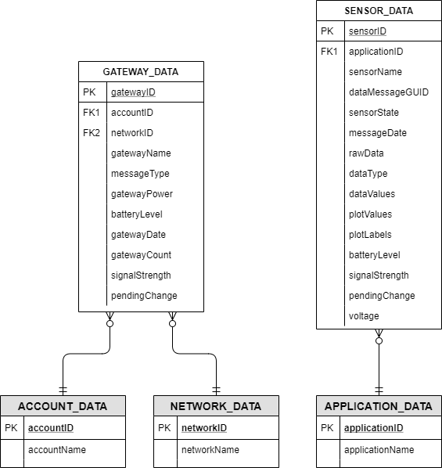

Sensor Data 1st Pass
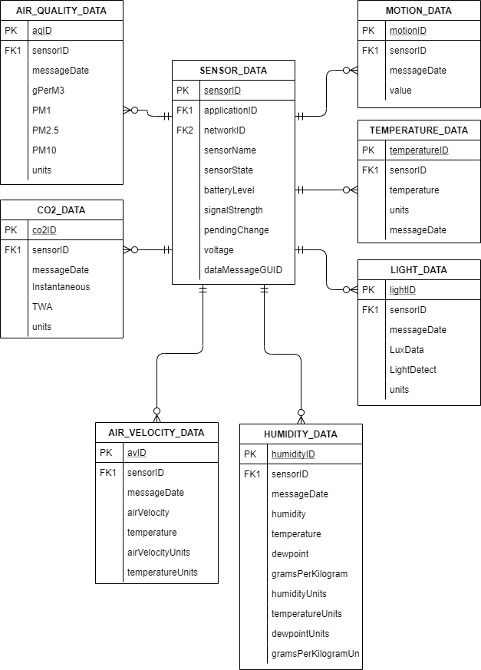

Sensor Data 2nd Pass
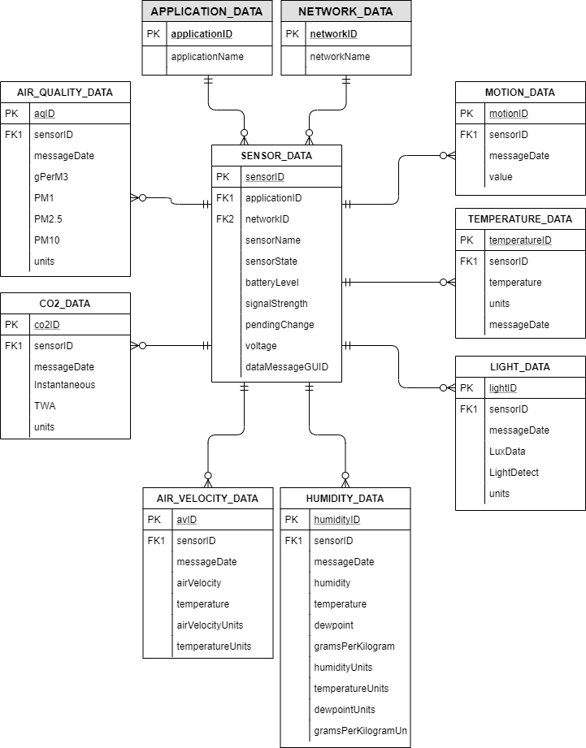

Sensor Data 3rd Pass
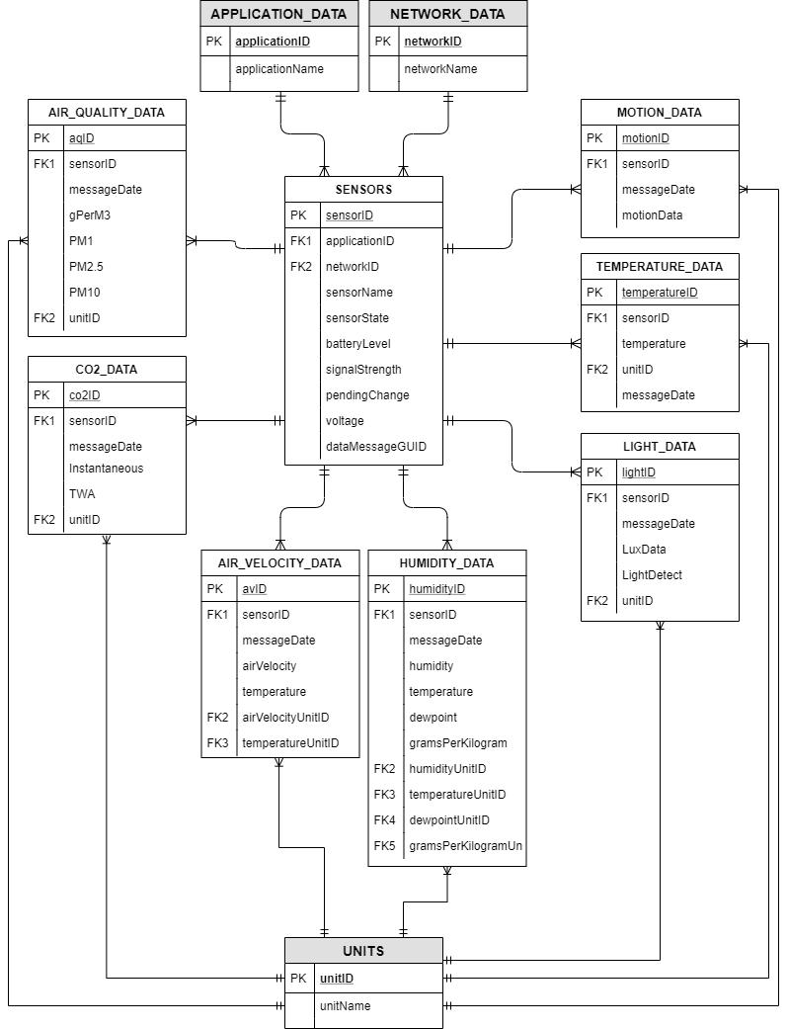

Corrected Sensor Data
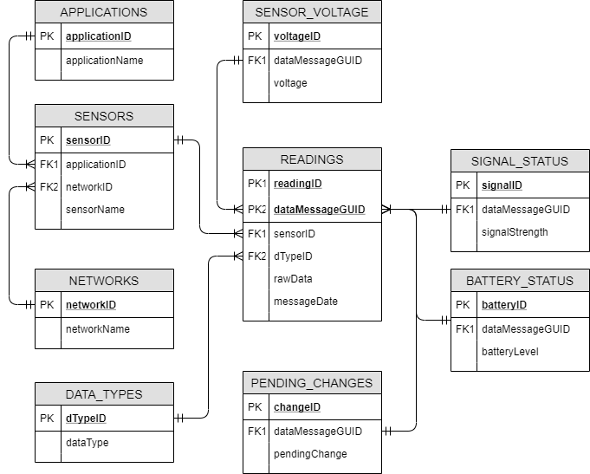

Corrected Sensor Data 2nd Pass
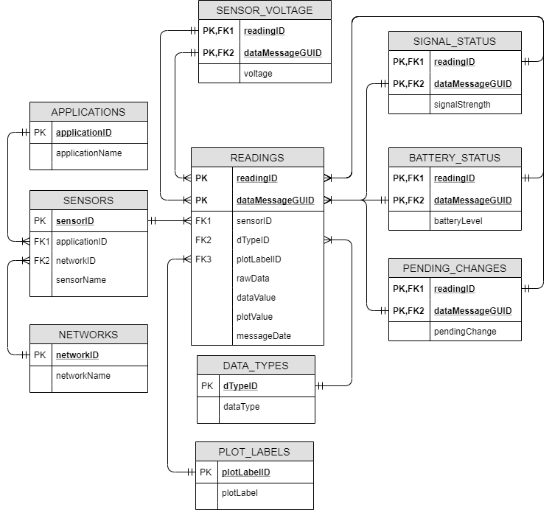

User Data
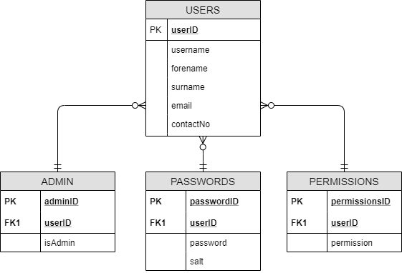

Data Dictionaries

Sensors

Sensors
Database: | salfordMove
Entity: | SENSORS
Definition: | Contains fixed data for individual sensors

Attribute | Key | Data Type | Size | Input Mask/Validation | Definition
sensorID | PK | GUID | - | N/A | GUID of a specific sensor, is unique because each sensor should only have one entry.
sensorName | - | NVARCHAR | 20 | N/A | The name of the sensor. Used for initially finding if a sensor exists in the DB.
applicationID | FK | INT | - | 00000 - 99999 | ID of the application that the sensor is associated with. (Data from MONNIT)
networkID | FK | INT | - | 00000 - 99999 | ID of the network that the sensor is associated with. (Data from MONNIT)

Readings
Database: | salfordMove
Entity: | READINGS
Definition: | Contains data relating to measurements collected by the installed sensors.

Attribute | Key | Data Type | Size | Input Mask/Validation | Definition
readingID | PK | GUID | - | N/A | GUID generated when a reading is written to the database.
dataMessageGUID | PK | GUID | - | N/A | GUID generated by MONNIT for a set of readings from a specific sensor. Some sensors have multiple measurands, so this field duplicates after data is split.
sensorID | FK | GUID | - | N/A | GUID for the sensor that collected the reading. Foreign key from Sensors table
rawData | - | NVARCHAR | 5 | N/A | The raw value recorded by the sensor.
dataValue | - | NVARCHAR | 5 | N/A | The value recorded by the sensor with respect to its data type. Actual difference from rawData unclear, likely interchangeable.
dataTypeID | FK | GUID | - | N/A | GUID for the data type of the current reading. Foreign key from Data Types table.
plotValue | - | NVARCHAR | 5 | N/A | The value recorded by the sensor with respect to its recorded Plot Label. Actual difference from rawData unclear, likely interchangeable.
plotLabelID | FK | GUID | - | N/A | GUID for the plot label of the current reading. Foreign key from Plot Labels table
messageDate | - | DATETIME | - | YYYY-MM-DD HH:MM:SS | The datetime when the reading was collected by the sensor.

Data Types
Database: | salfordMove
Entity: | DATA_TYPES
Definition: | Table for storing data relating to the data types of the readings stored in the Readings table

Attribute | Key | Data Type | Size | Input Mask/Validation | Definition
dTypeID | PK | GUID | - | N/A | GUID generated to identify a data type.
dataType | - | NVACHAR | 10 | N/A | The data type of a value in the Readings table.

Plot Labels
Database: | salfordMove
Entity: | PLOT_LABELS
Definition: | Table for storing data relating to the plot labels of the readings stored in the Readings table

Attribute | Key | Data Type | Size | Input Mask/Validation | Definition
plotLabelID | PK | GUID | - | N/A | GUID generated to identify a plot label.
dataType | - | NVARCHAR | 10 | N/A | The data type of a value in the Readings table.

Battery Status
Database: | salfordMove
Entity: | BATTERY_STATUS
Definition: | Table for storing the battery status of a sensor when a reading was taken.

Attribute | Key | Data Type | Size | Input Mask/Validation | Definition
readingID | PK/FK | GUID | - | N/A | GUID for a specific reading, referenced to the Readings table.  Used as part of a composite key.
dataMessageGUID | PK/FK | GUID | - | N/A | GUID from the MONNIT dataset identifying a specific set of readings, used as part of a composite key.
batteryLevel | - | INT | - | N/A | Integer reading of the battery level of the sensor when a reading was taken.

Signal Status
Database: | salfordMove
Entity: | SIGNAL_STATUS
Definition: | Table for storing the signal strength of a sensor when a reading was taken.

Attribute | Key | Data Type | Size | Input Mask/Validation | Definition
readingID | PK/FK | GUID | - | N/A | GUID for a specific reading, referenced to the Readings table.  Used as part of a composite key.
dataMessageGUID | PK/FK | GUID | - | N/A | GUID from the MONNIT dataset identifying a specific set of readings, used as part of a composite key.
signalStrength | - | FLOAT | - | N/A | Float representing the signal strength of a sensor when a reading was taken.

Pending Changes
Database: | salfordMove
Entity: | PENDING_CHANGES
Definition: | Table for storing if a sensor has any outstanding changes to be applied to its configuration when a reading was taken.

Attribute | Key | Data Type | Size | Input Mask/Validation | Definition
readingID | PK/FK | GUID | - | N/A | GUID for a specific reading, referenced to the Readings table.  Used as part of a composite key.
dataMessageGUID | PK/FK | GUID | - | N/A | GUID from the MONNIT dataset identifying a specific set of readings, used as part of a composite key.
pendingChange | - | BIT | - | N/A | Boolean/Bit representing if a change was scheduled or not.

Sensor Voltage
Database: | salfordMove
Entity: | VOLTAGE
Definition: | Table for storing the current voltage reading of a sensor when a reading was taken.

Attribute | Key | Data Type | Size | Input Mask/Validation | Definition
readingID | PK/FK | GUID | - | N/A | GUID for a specific reading, referenced to the Readings table.  Used as part of a composite key.
dataMessageGUID | PK/FK | GUID | - | N/A | GUID from the MONNIT dataset identifying a specific set of readings, used as part of a composite key.
voltage | - | FLOAT | - | N/A | Float representing the voltage level of a sensor when a reading was taken.

Miscellaneous

Applications
Database: | salfordMove
Entity: | APPLICATIONS
Definition: | Table for storing simple metadata about the applications the MONNIT sensors are assigned to. Data aggregated from MONNIT data JSON.

Attribute | Key | Data Type | Size | Input Mask/Validation | Definition
applicationID | PK | INT | - | 00000 - 99999 | ID of the application that the sensor is associated with. (Data from MONNIT)
applicationName | - | NVARCHAR | 20 | N/A | Name of an application.

Networks
Database: | salfordMove
Entity: | NETWORKS
Definition: | Table for storing simple metadata about the networks the MONNIT sensors are assigned to. Data aggregated from MONNIT data JSON.

Attribute | Key | Data Type | Size | Input Mask/Validation | Definition
networkID | PK | INT | - | 00000 - 99999 | ID of the network that the sensor is associated with. (Data from MONNIT)
networkName | - | NVARCHAR | 20 | N/A | Name of a network.

Accounts
Database: | salfordMove
Entity: | ACCOUNTS
Definition: | Table for storing simple metadata about the accounts the MONNIT sensors are assigned to. Data aggregated from MONNIT data JSON.

Attribute | Key | Data Type | Size | Input Mask/Validation | Definition
accountID | PK | INT | - | 00000 - 99999 | ID of the account that the gateway is associated with. (Data from MONNIT)
accountName | - | NVARCHAR | 20 | N/A | Name of an account.

Gateways
Database: | salfordMove
Entity: | GATEWAYS
Definition: | Data relating to gateways associated with the Monnit platform. Data is l

Attribute | Key | Data Type | Size | Input Mask/Validation | Definition
gatewayID | PK | INT | - | 000000 - 999999 | Integer generated by Monnit for identifying a specific gateway.
gatewayName | - | NVARCHAR | 20 | N/A | The name given to the gateway.
accountID | - | INT | - | N/A | Integer generated by Monnit for identifying an account the gateway is assigned to.
messageType | - | NVARCHAR | 100 | N/A | Data generated by Monnit. Unclear what its purpose is.
gatewayPower | - | INT | 20 | N/A | Likely represents if the gateway is online. Unclear why it’s recorded.
batteryLevel | - | INT | - | N/A | Integer reading of the battery level of the sensor when a reading was taken.
gatewayDate | - | DATETIME |  | N/A | The datetime of the gateway when the data was sent.
gatewayCount | - | INT | - | N/A | Data generated by Monnit. Unclear what its purpose is.
signalStrength | - | INT | - | N/A | Float representing the signal strength of a gateway when the data was sent.
pendingChange | - | BIT | - | N/A | Boolean/Bit representing if a change was scheduled or not.

Users

Users
Database: | salfordMove
Entity: | USERS
Definition:

Attribute | Key | Data Type | Size | Input Mask/Validation | Definition
userID | PK |  | - | =>000001 And =<900000
Username | - |  | 50 | N/A
Forename | - |  | 50 | N/A
Surname | - |  | 128 | N/A
Email | - |  | 20 | VALID-EMAIL
contactNo

Admins
Database: | salfordMove
Entity: | ADMINS
Definition:

Attribute | Key | Data Type | Size | Input Mask/Validation | Definition
adminID | PK |  | - | =>000001 And =<900000
userID* | - |  | 50 | N/A
isAdmin | - |  | 50 | N/A
 | - |  | 128 | N/A
 | - |  | 20 | N/A

Passwords
Database: | salfordMove
Entity: | PASSWORDS
Definition:

Attribute | Key | Data Type | Size | Input Mask/Validation | Definition
passwordID | PK |  | - | =>000001 And =<900000
userID* | - |  | 50 | N/A
Password | - |  | 50 | N/A
salt | - |  | 128 | N/A
 | - |  | 20 | N/A

Permissions
Database: | salfordMove
Entity: | PERMISSIONS
Definition:

Attribute | Key | Data Type | Size | Input Mask/Validation | Definition
permissionsID | PK |  | - | =>000001 And =<900000
userID* | - |  | 50 | N/A
Permissions | - |  | 50 | N/A
 | - |  | 128 | N/A
 | - |  | 20 | N/A

Future Work

Location Included Normalisation
The current normalised data form does its job in breaking the available data down into non-repeating forms it does not take the physical locations of the sensors into account.
A further round of normalisation can be performed on top of the current final normalised form to introduce two new tables for the physical location and the zone of a sensor or gateway, as it would allow sensors installed in different museums to be easily separated.
Additional separation of the data in this manner will require additional processing of the data and will be heavily dependent on the naming scheme of the sensors connected to the platform for example using the ‘AQ - Z01 - NA – 498841’ sensor will require the sensors name to be parsed and the ‘Z01’ to be used to associate the sensor with its zone.
For sensors installed in the GEM to be processed an additional tag will need to be included in the names of the sensors that are to be installed in the museum for example a sensor named ‘AQ - Z01 - NA – 498841’ would need to be set to ‘AQ - Z01 - NA – 498841 – GEM’ instead.

This can also be achieved using the sensor ID included in the name of every sensor, and this could be a more efficient method of separating the sensors but will require an extensive list of sensors and locations to be assembled beforehand.

Gateway Data Normalisation
Data relating to the Monnit gateways has not been normalised because it isn’t used as part of the frontend dashboard and doesn’t include data with concatenated measurands.
A complete normalisation of the gateway is advisable because the system is put into production just to improve the efficiency of the database storage, but this is a low priority at this time.

